

**WIC2001 Advanced Network Technology**  
Faculty of Computer Science and Information Technology  
University of Malaya

**Lab Test Documentation**

**Prepared by**Muhammad Azri bin Zainuddin (WER150018)

Lecturer’s Name

Associate Prof. Dr. Ling Teck Chaw

**Physical Topology**

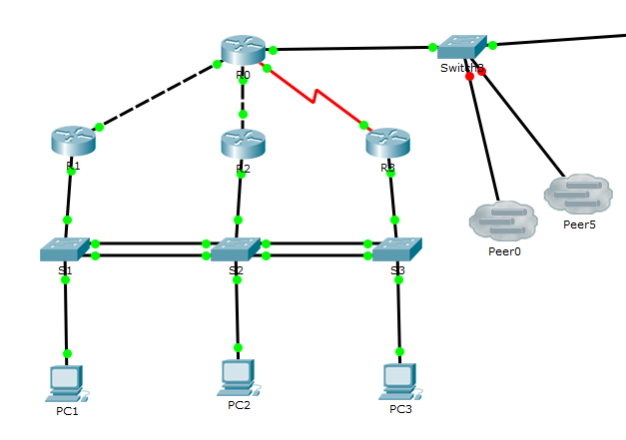

1. **Plan and record clearly Device names, Interfaces (include L0), IP addresses/subnet Mask, Default gateway and Switch port in the IP Addressing table below**

**IP Addressing Table**

|  |  |  |  |  |  |
| --- | --- | --- | --- | --- | --- |
| **Device/ Vlan/ Area** | **Interface** | **IP Address** | **Subnet Mask** | **Default Gateway** | **Switch Port** |
| **PC1** | Fa0 | 138.16.11.11 | 255.255.255.0 | 138.16.11.254 | Fa0/1 |
|  | 2001:138:16:11::11/64 |  | 2001:138:16:11::/64 |  |
|  | | | | | |
| **PC2** | Fa0 | 138.16.12.12 | 255.255.255.0 | 138.16.12.254 | Fa0/1 |
|  | 2001:138:16:12::12/64 |  | 2001:138:16:12::/64 |  |
|  | | | | | |
| **PC3** | Fa0 | 138.16.13.13 | 255.255.255.0 | 138.16.13.254 | Fa0/1 |
|  | 2001:138:16:13::13/64 |  | 2001:138:16:13::/64 |  |
|  | | | | | |
| **VLAN 161** | - | 138.16.11.161 | 255.255.255.0 | - | - |
|  | 2001:138:16:11::161/64 |  |  |  |
| **VLAN 162** | - | 138.16.12.162 | 255.255.255.0 | - | - |
|  | 2001:138:16:12::162/64 |  |  |  |
| **VLAN 163** | - | 138.16.13.163 | 255.255.255.0 | - | - |
|  | 2001:138:16:13::163/64 |  |  |  |
|  | | | | | |
| **R0** | Lo0 | 138.16.10.250 | 255.255.255.255 | - | - |
|  | 2001:138:16:FF::/128 | - | - | - |
| Gig0/0 | 74.33.21.16 | 255.255.255.0 | - | - |
|  | 2001:138:F::16/64 | - | - | - |
|  | FE80::16 (link local) | - | - | - |
| Gig0/1 | 138.16.255.1 | 255.255.255.252 | - | - |
|  | 2001:138:16:F::/127 | - | - | - |
| Gig0/2 | 138.16.255.5 | 255.255.255.252 | - | - |
|  | 2001:138:16:F::2/127 | - | - | - |
| S0/0/0 | 138.16.255.9 | 255.255.255.252 | - | - |
|  | 2001:138:16:F::4/127 | - | - | - |
|  | | | | | |
| **R1** | Lo0 | 138.16.10.251 | 255.255.255.255 | - | - |
|  | 2001:138:16:FF::1/128 | - | - | - |
| Gig0/0.1 | 138.16.11.254 | 255.255.255.0 | - | Fa0/4 |
|  | 2001:138:16:11::/64 | - | - |  |
| Gig0/0.2 | 138.16.12.254 | 255.255.255.0 |  | Fa0/4 |
|  | 2001:138:16:12::/64 | - | - | - |
| Gig0/0.3 | 138.16.13.254 | 255.255.255.0 | - | Fa0/4 |
|  | 2001:128:16:13::/64 | - | - | - |
| Gig0/1 | 138.16.255.2 | 255.255.255.252 | - | - |
|  | 2001:138:16:F::1//127 | - | - | - |
|  | | | | | |
| **R2** | Lo0 | 138.16.10.252 | 255.255.255.255 | - | - |
|  | 2001:138:16:FF::2/128 | - | - | - |
| Gig0/0.1 | 138.16.11.254 | 255.255.255.0 | - | Fa0/4 |
|  | 2001:138:16:11::/64 | - | - |  |
| Gig0/0.2 | 138.16.12.254 | 255.255.255.0 |  | Fa0/4 |
|  | 2001:138:16:12::/64 | - | - | - |
| Gig0/0.3 | 138.16.13.254 | 255.255.255.0 | - | Fa0/4 |
|  | 2001:128:16:13::/64 | - | - | - |
| Gig0/1 | 138.16.255.6 | 255.255.255.252 | - | - |
|  | 2001:138:16:F::3//127 | - | - | - |
|  | | | | | |
| **R3** | Lo0 | 138.16.10.253 | 255.255.255.255 | - | - |
|  | 2001:138:16:FF::3/128 | - | - | - |
| Gig0/0.1 | 138.16.11.254 | 255.255.255.0 | - | Fa0/4 |
|  | 2001:138:16:11::/64 | - | - |  |
| Gig0/0.2 | 138.16.12.254 | 255.255.255.0 |  | Fa0/4 |
|  | 2001:138:16:12::/64 | - | - | - |
| Gig0/0.3 | 138.16.13.254 | 255.255.255.0 | - | Fa0/4 |
|  | 2001:128:16:13::/64 | - | - | - |
| S0/0/1 | 138.16.255.10 | 255.255.255.252 | - | - |
|  | 2001:138:16:F::5/127 | - | - | - |

1. **Configure OSPF**

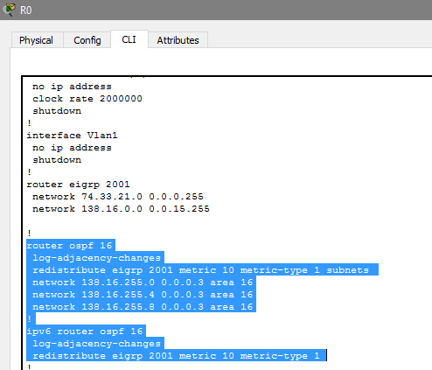

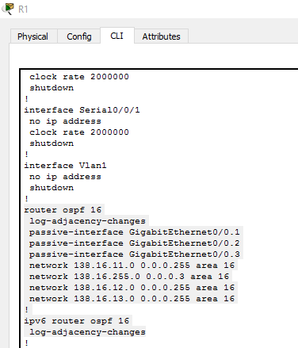

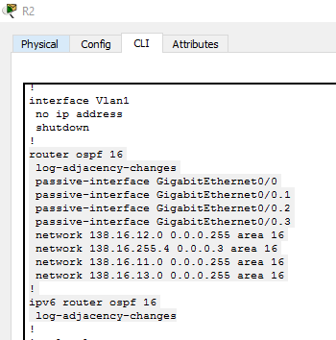

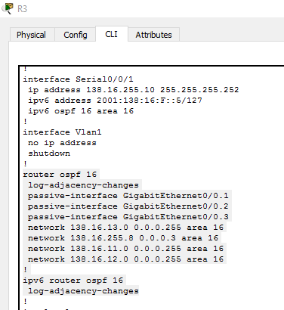

1. **Configure EIGRP and publish only summarized address**

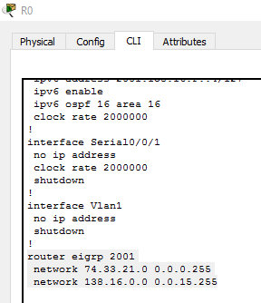

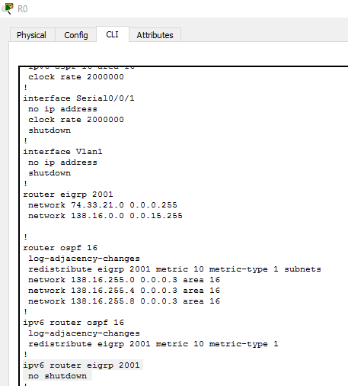

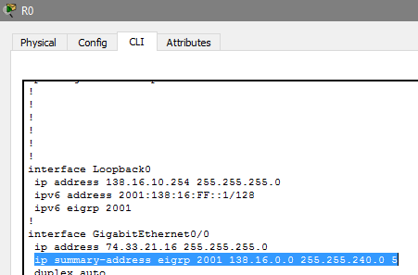

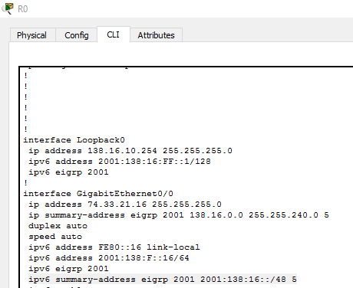

1. **Redistribute routes between EIGRP and OSPF**

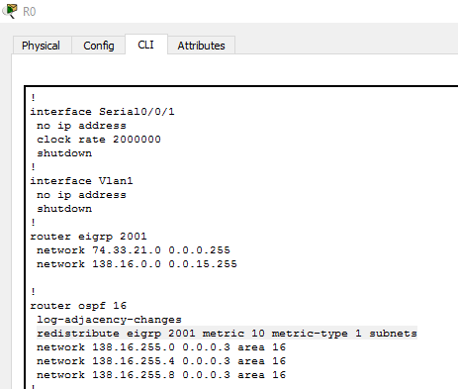

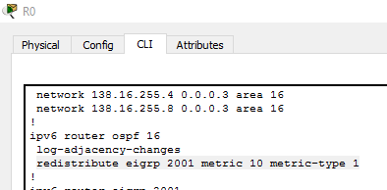

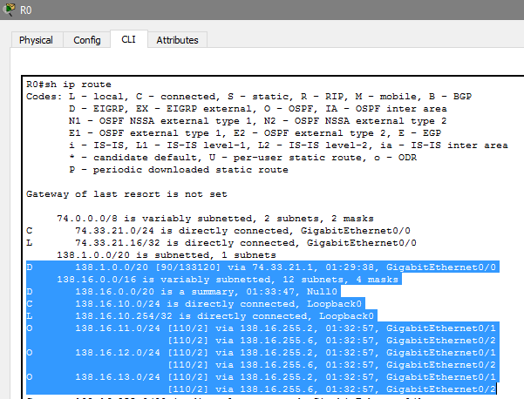

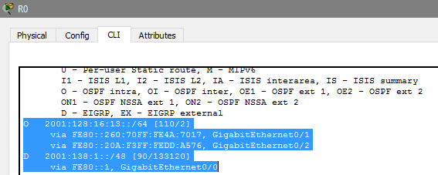

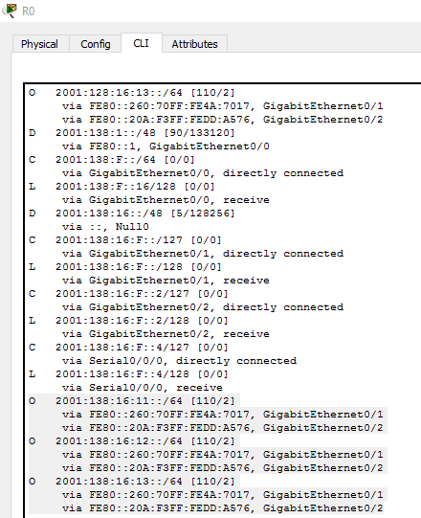

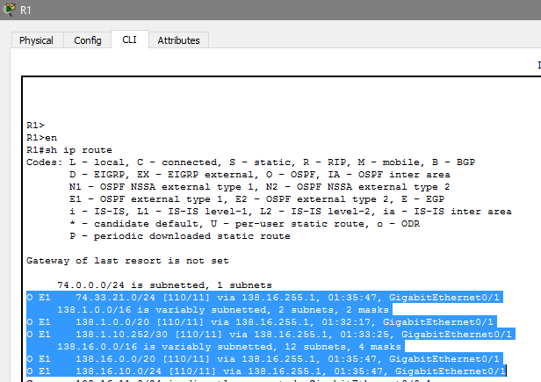

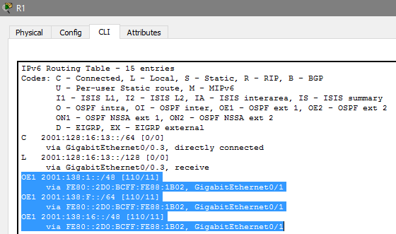

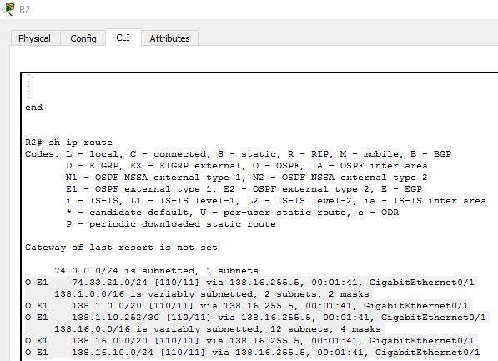

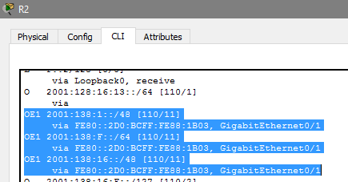

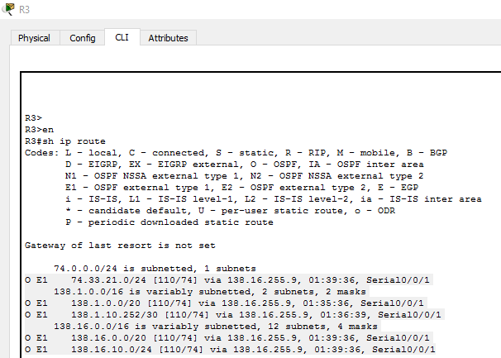

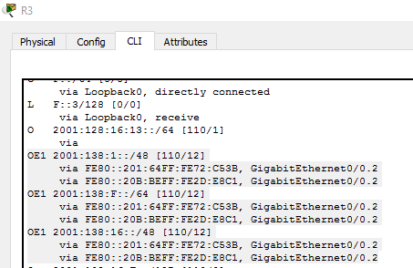

1. **Configure EtherChannel**

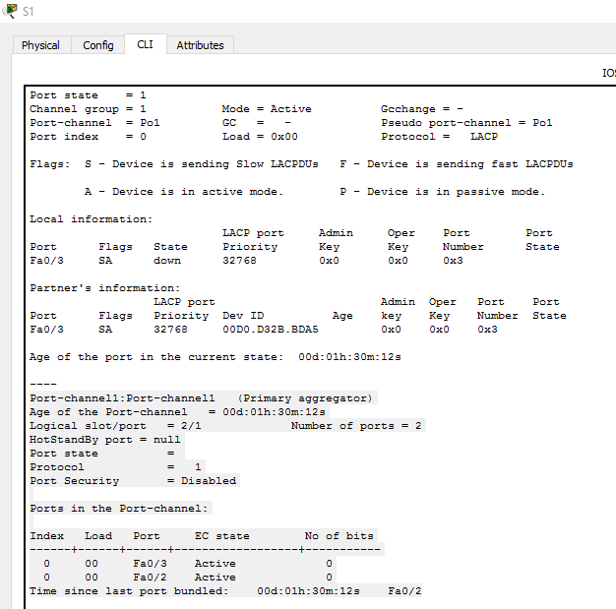

1. **Configure VTP and PVSTP+**

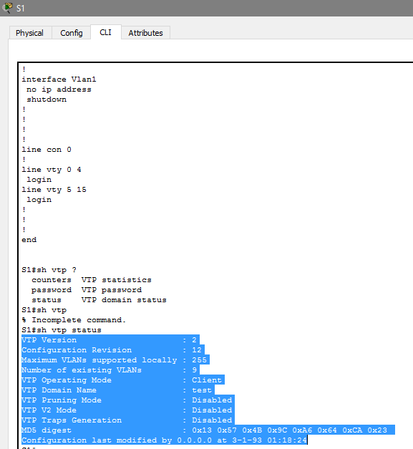

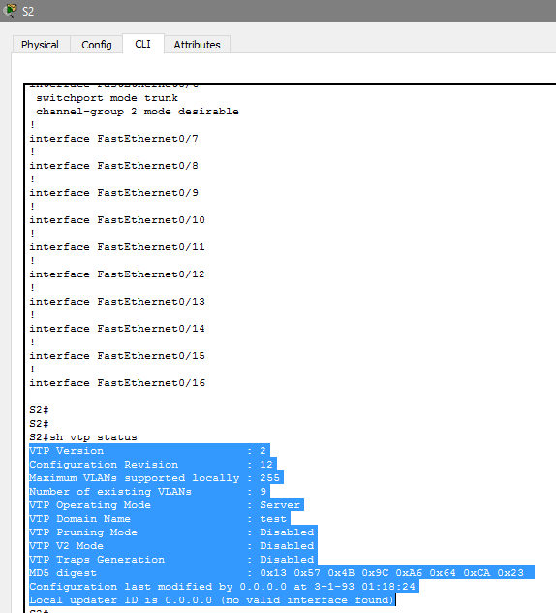

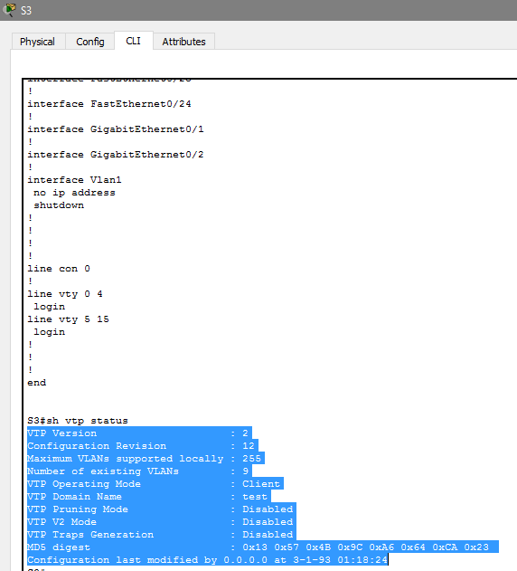

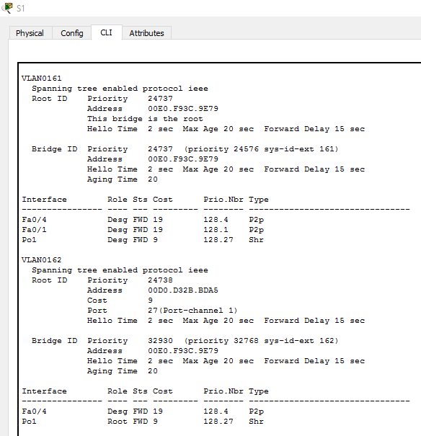

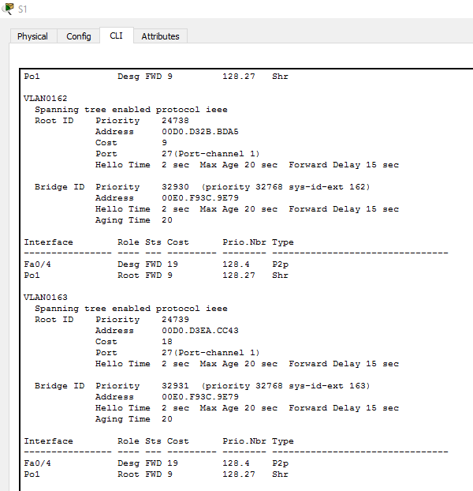

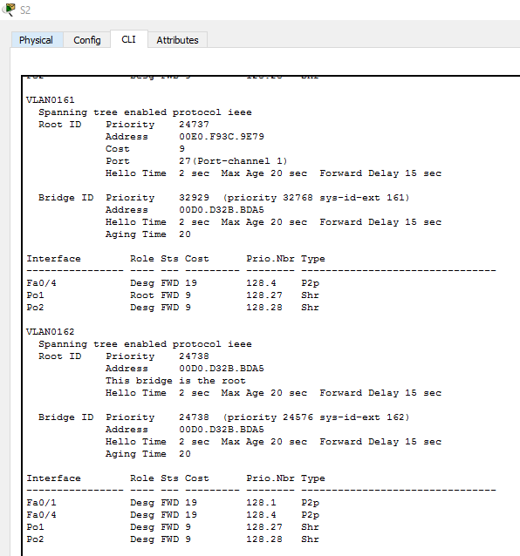

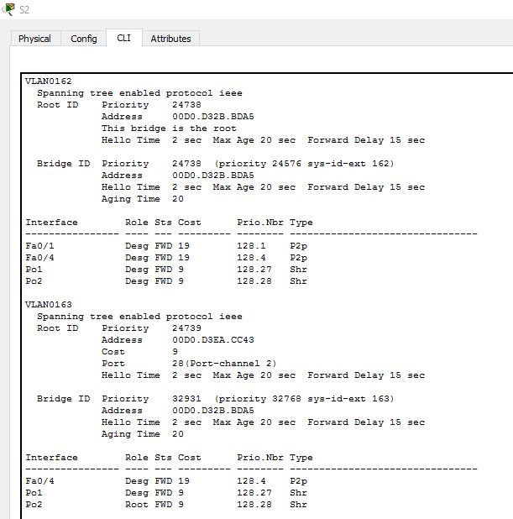

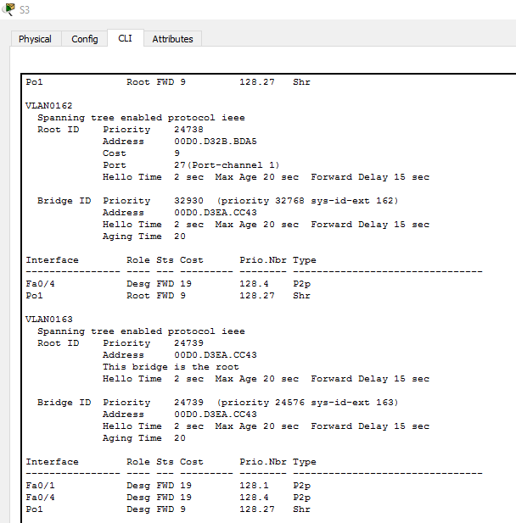

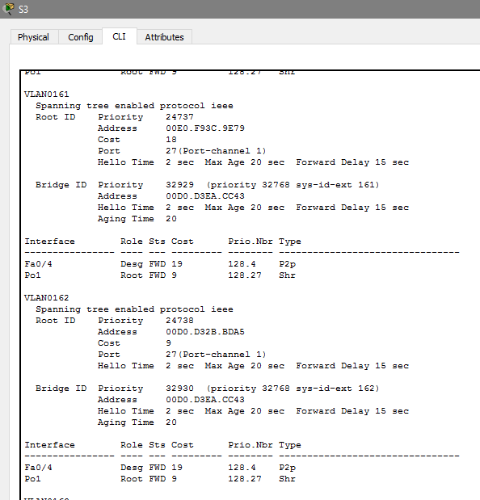

1. **Configure HSRP (3 marks)**

